**NURSERY MANAGEMENT SYSTEM**

A project report submitted to Sri Ramakrishna Mission Vidyalaya

College of Arts and Science, Coimbatore - 641 020 in partial fulfillment of the requirements for the award of the Degree of

**BACHELOR OF SCIENCE IN COMPUTER SCIENCE**

Submitted by

**SARAN P**

**Reg. No.: 21USC020**

*Under the guidance of*

**Dr. J. YESUDOSS,MCA., M.Phil., Ph.D.,**

**Assistant Professor**

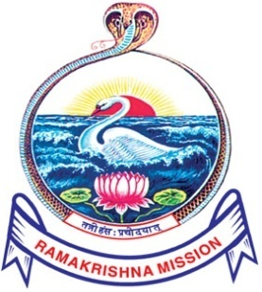

**DEPARTMENT OF COMPUTER SCIENCE (SF)**

**SRI RAMAKRISHNA MISSION VIDYALAYA COLLEGE OF ARTS AND SCIENCE**

*(An Autonomous Institution Affiliated to Bharathiar University,*

*Re-Accredited by NAAC with A+ Grade)*

**COIMBATORE - 641 020**

**APRIL - 2024**